Linux Assignment -1

Name : Monish Kanna K
Reg.No : 611222104094
College : KIOT
Linux basic commands
Q.No 1
User Management & File Inspection
Write a Bash script that creates a new user, sets a password, and verifies the user’s entry in /etc/passwd using grep. What command would you use to check the file type before opening it?
CODE :
#!/bin/bash
echo "New user Account Createion"
read -p "Enter a user name: " UserName
sudo useradd $UserName
if [ $? -eq 0 ]
then
echo "Username created Successfully"
else
echo "User creation failed"
exit 1
fi
sudo passwd $UserName
echo "Verifying username entry in /etc/passwd"
grep $UserName /etc/passwd
echo "Checking filetype of /etc/passwd"
file /etc/passwd

OUTPUT :

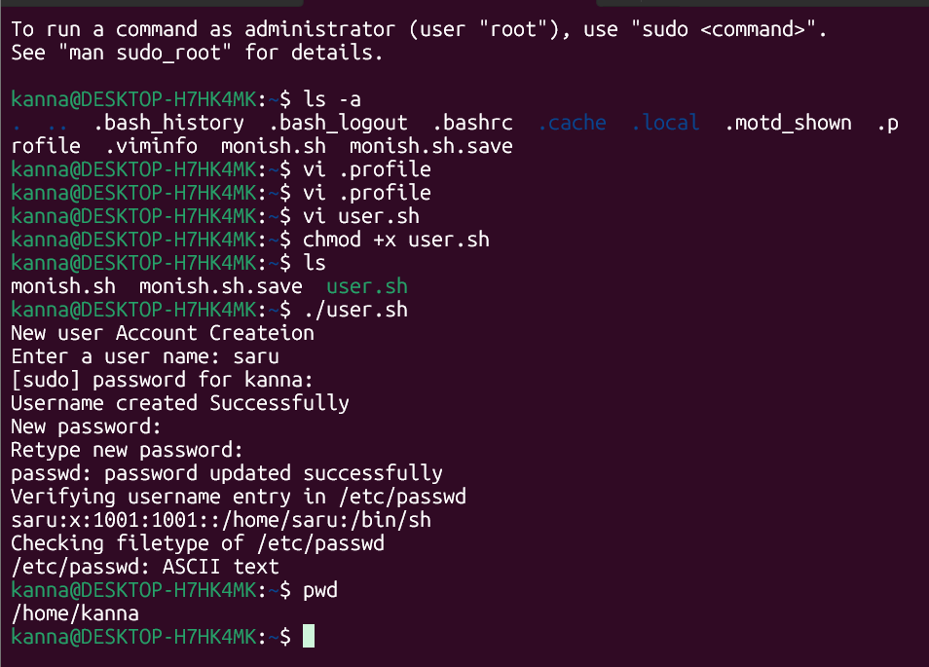

Q.No 2
Environment Variables and Shell Configuration
Modify .bash_profile to include a custom greeting and a new environment variable. How would you ensure the variable is available in child shells?
CODE:
echo " Hello Monish kanna how are you ? "
export MYVAR="Linux Learning Platform"
Using export command we can make the variable as an environment variable and access the variable in child shells.

OUTPUT :
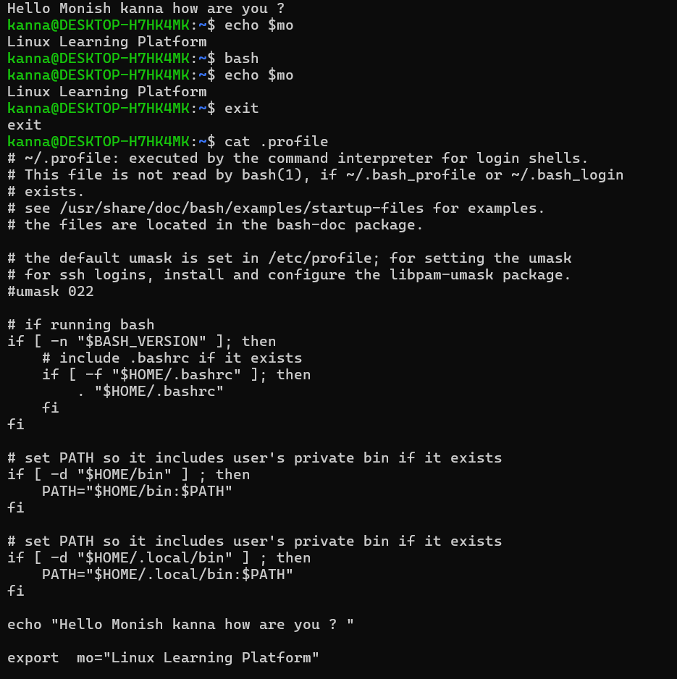
Q.No 3
Redirection Operators
Create a script that collects system information using uname -a and ip a, and saves it to a file. Ensure that the output is appended, not overwritten. How would you redirect both STDOUT and STDERR to the same file?
CODE :
#!/bin/bash
echo " System Information File"
touch newfile.txt
uname -a >> newlog.txt 2>&1
ip a >> newfile.txt 2>&1
echo "Data saved to newfile.txt. You can view it now "
OUTPUT :
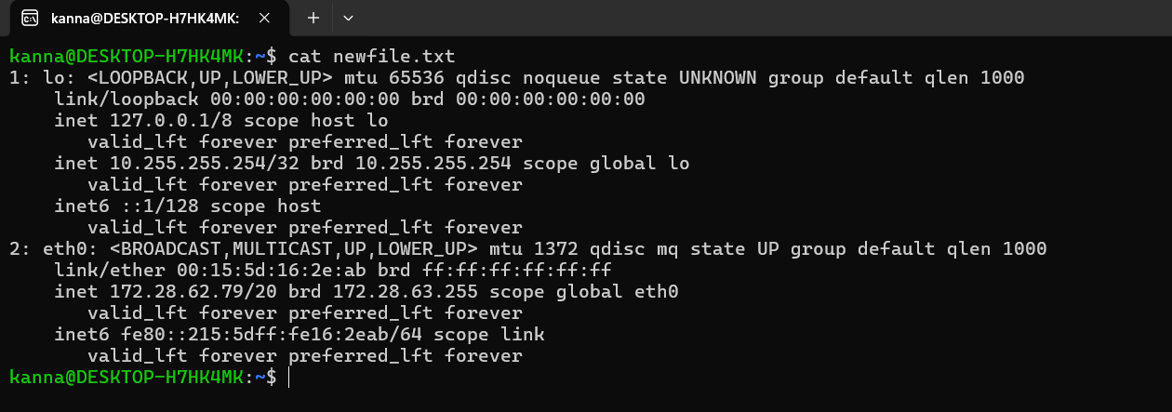

Q.No 4:
Positional Parameters
Create a script that accepts four arguments: profession, age, city, and name. Use positional parameters to print a formatted sentence using these inputs.
CODE :
#!/bin/bash
profession=$1
age=$2
city=$3
name=$4
echo "Hi, my name is $4, i am $2 years old working as a $1 and live in $3".

OUTPUT :

Q.No 5
Control Operators
Write a script that checks if a file exists and prints a message using &&. Then modify it to print a different message if the file does not exist using ||.
CODE :
#!/bin/bash
file="detail.sh"
[ -f "$file" ] && echo "The file exists." || echo "The file does not exist."
file1="sample.txt"
[ -f "$file1" ] && echo "The file exists." || echo "The file does not exist."
OUTPUT :
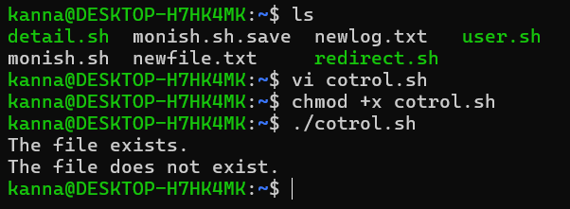

Linux shell Scripting Assignment BASIC
1. Write a script that declares two variables, adds them together, and prints the result. Explain how variable assignment works in Bash.
CODE :
#!/bin/bash
a=10
b=20
sum=$((a + b))
echo "The sum is: $sum"

2. WAP to find the perimeter of a rectangle if length and breadth are given.
CODE :
#!/bin/bash
echo "Enter length:"
read length
echo "Enter breadth:"
read breadth
perimeter=$((2 * (length + breadth)))
echo "Perimeter of rectangle is: $perimeter”

OUTPUT :
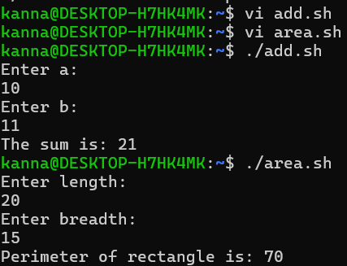

IF
1. WAP to check whether the product of two given numbers is odd or even.
CODE :
#!/bin/bash
echo "Enter first number:"
read a
echo "Enter second number:"
read b
product=$((a * b))

if [ $((product % 2)) -eq 0 ]
then
echo "Product is Even"
else
echo "Product is Odd"
fi
2. WAP to check whether the entered number is multiple of 5.
CODE :
#!/bin/bash
echo "Enter a number:"
read num
if [ $((num % 5)) -eq 0 ]
then
echo "Number is multiple of 5"
else
echo "Number is NOT multiple of 5"
fi
3. WAP, given three sides of a triangle, to check whether the triangle is perfect right triangle.
CODE :
#!/bin/bash
echo "Enter three sides:"
read a b c
if [ $((a*a + b*b)) -eq $((c*c)) ] || \
[ $((a*a + c*c)) -eq $((b*b)) ] || \
[ $((b*b + c*c)) -eq $((a*a)) ]
then
echo "It is a Perfect Right Triangle"
else
echo "It is NOT a Perfect Right Triangle"
fi

4. WAP to check whether given year is leap year or not.
CODE :
#!/bin/bash
echo "Enter year:"
read year
if [ $((year % 400)) -eq 0 ] || \
{ [ $((year % 4)) -eq 0 ] && [ $((year % 100)) -ne 0 ]; }
then
echo "Leap Year"
else
echo "Not a Leap Year"
fi
5. WAP that reads in 2 integers and determines and prints if the first is a multiple of the second.
CODE :
#!/bin/bash
echo "Enter first number:"
read a
echo "Enter second number:"
read b
if [ $((a % b)) -eq 0 ]
then
echo "$a is a multiple of $b"
else
echo "$a is NOT a multiple of $b"
fi

OUTPUT :
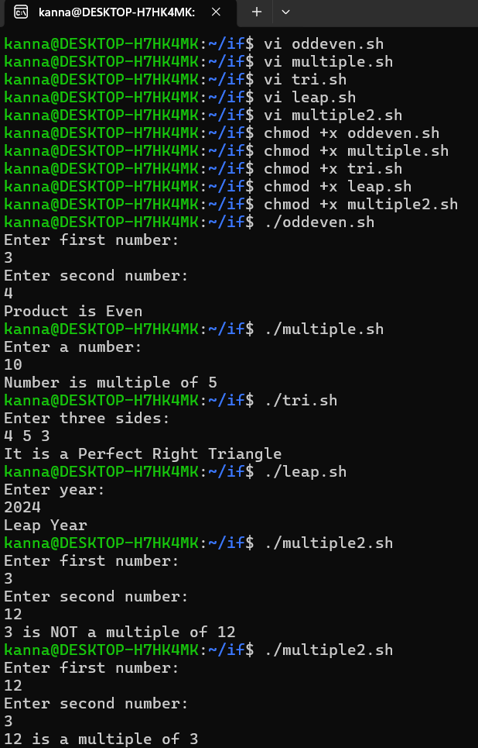

1.Smallest and Largest of n Numbers
CODE :
#!/bin/bash
echo "Enter how many numbers:"
read n
echo "Enter number 1:"
read num
small=$num
large=$num
for ((i=2; i<=n; i++))
do
echo "Enter number $i:"
read num
if [ $num -lt $small ]
then
small=$num
fi
if [ $num -gt $large ]
then
large=$num
fi
done
echo "Smallest number: $small"
echo "Largest number: $large"
2. Print Even Numbers from 1 to 100
CODE :
#!/bin/bash
for ((i=2; i<=100; i+=2))
do
echo $i
done
3.Check Prime Number
CODE :
#!/bin/bash
echo "Enter a number:"
read num
flag=0
for ((i=2; i<=num/2; i++))
do
if [ $((num % i)) -eq 0 ]
then
flag=1
break
fi
done
if [ $num -le 1 ]
then
echo "Not Prime"
elif [ $flag -eq 0 ]
then
echo "Prime Number"
else
echo "Not Prime"
fi
4.Sum and Average of n Numbers
CODE :
#!/bin/bash
echo "Enter how many numbers:"
read n
sum=0
for ((i=1; i<=n; i++))
do
echo "Enter number $i:"
read num
sum=$((sum + num))
done
average=$((sum / n))
echo "Sum: $sum"
echo "Average: $average"
5.Print Numbers from m to n
CODE :
#!/bin/bash
echo "Enter starting number (m):"
read m
echo "Enter ending number (n):"
read n
while [ $m -le $n ]
do
echo $m
m=$((m + 1))
done

OUTPUT :
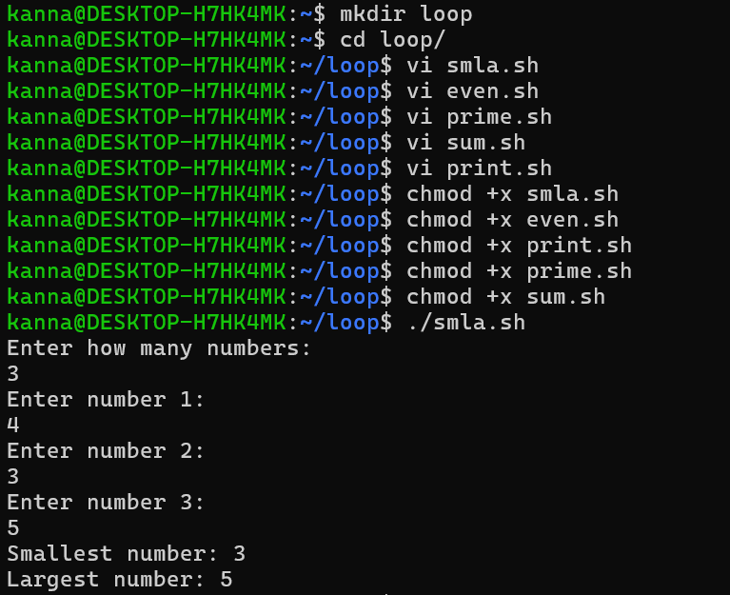
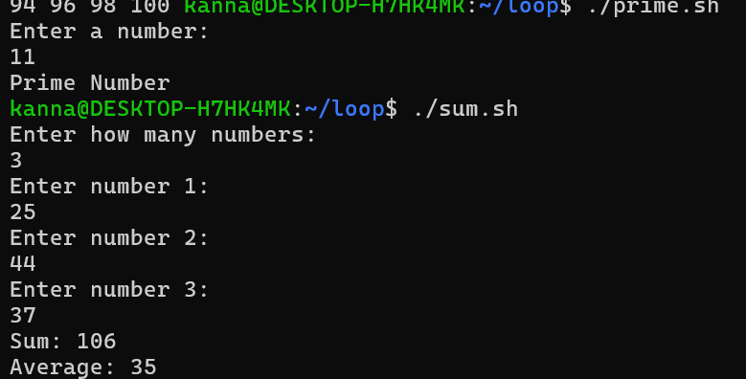
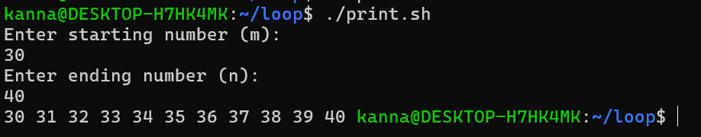
1) Write a simple script using case that prints the day of the week based on user input (1 = Monday, 2 = Tuesday, etc.).
CODE:
#!/bin/bash
echo "Enter a number (1-7): "
read day
case $day in
1) echo "Monday" ;;
2) echo "Tuesday" ;;
3) echo "Wednesday" ;;
4) echo "Thursday" ;;
5) echo "Friday" ;;
6) echo "Saturday" ;;
7) echo "Sunday" ;;
*) echo "Invalid input! Enter 1-7 only." ;;
esac
2) Write a script that takes two numbers and an operator (+, -, , /) as input. Use a case statement to perform the arithmetic operation.
CODE:
#!/bin/bash
echo "Enter first number: "
read num1
echo "Enter second number: "
read num2
echo "Enter operator (+, -, *, /): "
read op
case $op in
+) echo "Result = $((num1 + num2))" ;;
-) echo "Result = $((num1 - num2))" ;;
\*) echo "Result = $((num1 * num2))" ;;
/)
if [ $num2 -ne 0 ]
then
echo "Result = $((num1 / num2))"
else
echo "Error: Division by zero!"
fi
;;
*) echo "Invalid operator!" ;;
esac
3) Traffic Light Simulation: Input can be red, yellow, or green. Use case statement to print appropriate action.
CODE:
#!/bin/bash
echo "Enter traffic light color (red/yellow/green): "
read color
case $color in
red) echo "Stop" ;;
yellow) echo "Get Ready" ;;
green) echo "Go" ;;
*) echo "Invalid input! Enter red, yellow, or green." ;;
Esac

OUTPUT :
